Subject Line: [COMPANY NAME] Pulse Check

Email Copy:

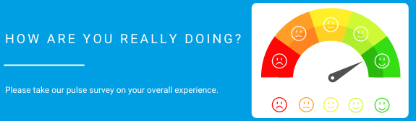

Hi [COMPANY NAME] Team,

Hope everyone is having a great start to the new year and took some time to rest and recoup! We wanted to do a quick pulse check of how your experience at [COMPANY NAME] has been. Please take the following survey to help us provide you the best work experience possible. The survey is completely anonymous and will help us see how we can better support you. This is your chance to share with us how you feel about your employee experience and provide meaningful guidance to improve it moving forward.

Please reach out to us with any questions or concerns you may have.

Best,

[Name of person here]

